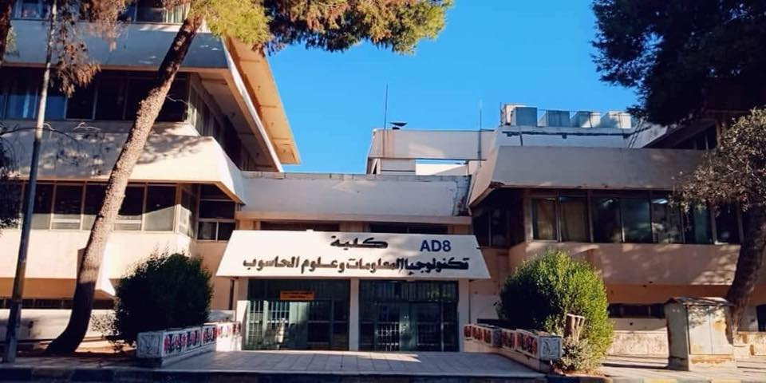

Smart Box

Smart incubator environment for growing

seasonal plants

Smart Box | Graduation Project | 2021

FINAL YEAR GRADUATION PROJECT



Computer Science Department

Faculty of Information Technology and Computer Science

Yarmouk University

Irbid, Jordan

**

*BSc Project*

*CS Department*

*Project ID: YUIT-CS–XX-XXX*

**SMART BOX**

**Haitham Odeh 2017901147**

**Year 2020/2021**

Department of Computer Science

Faculty of Information Technology and Computer Sciences

Yarmouk University, Jordan

***Contact Information***

***Author(s):***

***Haitham Odeh,*** *(2017901147)*

*E-mail:* [*haitham1999_odeh@hotmail.com*](mailto:haitham1999_odeh@hotmail.com)

***University supervisor(s):***

*Dr. Mustafa Bani Khalaf*

*Department of Computer Science Internet: http://yu.edu.jo*

*Faculty of Information Technology Phone: +962 2 72711111 Ext. 6710*

*and Computer Science*

*Yarmouk University Fax: +962 2 7211111*

*Jordan*

**Intellectual Property Right Declaration**

*This is to declare that the work under the supervision of dr. Mustafa Bani Khalaf having title” Smart Box” carried out in partial fulfillment of the requirements of Bachelor of Information Technology in Computer Science, is the sole property of the Yarmouk University and the respective supervisor and is protected under the intellectual property right laws and conventions. It can only be considered/ used for purposes like extension for further enhancement, product development, adoption for commercial/organizational usage, etc., with the permission of the University and respective supervisor.*

*This above statement applies to all students and faculty members.*

*Date: 16/5/2021*

|  |  |  |  |  |  |  |  |  |  |  |  |
| --- | --- | --- | --- | --- | --- | --- | --- | --- | --- | --- | --- |
| |  |  | | --- | --- | | ***Author(s):*** | | | *Name: Haitham Odeh* | *Signature: _____________________* | |  |  | |  |  | |  |  | | |
|  |
|  |

***Supervisor(s):***

*Name: Mustafa Bani Khalaf Signature: _____________________*

**Anti-Plagiarism Declaration**

This is to declare that the above publication produced under the supervision of dr. Mustafa Bani Khalaf having title “Smart Box” is the sole contribution of the author(s) and no part hereof has been reproduced illegally (cut and paste) which can be considered as Plagiarism. All referenced parts have been used to argue the idea and have been cited properly. I/We will be responsible and liable for any consequence if violation of this declaration is proven.

Date:16/5/2021

**ACKNOWLEDGMENTS**

First and foremost, praises and thanks to the God, the Almighty, for His showers of blessings throughout our research work to complete it successfully.

We would like to express my deep and sincere gratitude to our project supervisor, Dr. Mustafa Bani Khalaf, for guidance throughout this project. His dynamism, vision, sincerity and motivation have deeply inspired us. He has taught us the methodology to carry out the project and to present the research works as clearly as possible. It was a great privilege and honor to work and study under his guidance. We are extremely grateful for what he has offered us. We would also like to thank him for his friendship, empathy.

And we are extremely grateful to our parents for their love, prayers, caring and sacrifices for educating and preparing us for our future.

Finally, our thanks go to all the people who have supported us to complete the

research work directly or indirectly.

**Smart Box team,**

**ABSTRACT**

The main intention of “Smart plant Box application and plant box” is to help people to grow their own food and seasonal vegetables such as Mushroom with no experience with farming and with no interact throw growing process due to the huge climate change and the due to the agricultural area is gradually decreasing. they can control and monitor their own plants from any android smartphone’s by using the application they can buy plant boxes and start a step on the way of healthy life.

the following three challenges to the future of agriculture:

* Resource Depletion: The Costs of Industrial Agriculture
* Land Management: Degrading and Undervaluing Farmland
* Demographic Changes: A Disconnected Public

So, in the constantly innovating world of agriculture, growers need to take advantage of every tool at their disposal. Digital record keeping, monitoring, and so many aspects of farm operations can be enhanced with our app we have added benefit of being accessible from anywhere with a mobile data connection. Access to accurate information allows growers to harness the power of data to make the best decisions for their operations.

Contents

**Chapter 1**

purpose of the project 10

Purpose of this Document 10

Overview of this Document 10

Existing System 10

Existing system description 11

Problems in the existing system 11

Chapter 2

2.1 Data Analysis 12

2.1.1 Data flow diagram 12

Level 1 data flow diagram 13

2.1.2 System requirements 13

2.1.2.1 Use-case Diagrams 14

2.1.2.2 Functional and data requirements 16

2.1.2.3 Non-functional requirements 16

2.1.2.3.1 Look and feel requirements 16

2.1.2.3.2 Usability requirements 16

2.1.2.3.3 Security requirements 16

2.1.2.3.4 Portability requirements 17

2.1.3 Class Diagrams 17

2.1.4 Proposed Solutions 17

2.1.5 Alternative Solutions 17

Chapter 3

3.1 Design constraints 18

3.1.1 Hardware and software environment 18

3.1.2 End user characteristics 18

3.2 Architectural Strategies 19

3.2.1 Algorithm to be used 19

NTP Protocol 23

3.2.2 Project management strategies 24

3.2.3 Development method 24

3.2.4 Future enhancements/plans 25

Chapter 4

4.1Architecture and Program Flow 25

4.2.1 Detailed System Design 27

4.2.2Detailed component description 31

chapter5

Code Of Android studio**:** 34

Code Of Hardware (Arduino): 44

Code of Python (ML): 47

# Chapter 1: Introduction

## purpose of the project

With the development of practical life, traditional agriculture has become a burden on the farmer, and the agricultural area is gradually decreasing, in addition to the fact that many people in cities suffer from the lack of suitable agricultural areas, and also many suffer from the lack of a suitable environment for agriculture such as dry and desert areas. and cold, also they may not have the necessary experience to keep up with the planting process.

That is why we made our idea come to life through this project to help provide an appropriate environment for planting and growing plants, such as seasonal plants and plants that need special environments, as well as mushroom cultivation, due to the difficulty of cultivation and the difficulty of creating the appropriate conditions and controlling the surrounding environment, and the need for high experience.

## Purpose of this Document

The aim of this document is to define the methodological steps, techniques, algorithms, and programs that we have worked on to reach a final product,

In addition to documenting the project in terms of business, and presenting all analyzes of the business model and business plan.

Project objectives:

1. Easy to use for who need to buy the product
2. Reasonable cost
3. Efficient
4. Suitable size

## Overview of this Document

First, we will present the project details in terms of the idea and the target market, then on the project components and the electronic parts used in it, then a detailed explanation of the application and how it connects to the box through the IoT and Wireless feature, directly reading the data and controlling the box through electronic parts such as lighting, pump, ventilation, etc.

And we will review the most important algorithms that we worked on and finally the names of the programs and sites that we worked with, in addition to references and summaries.

## Existing System

An isolated smart box specialized in agricultural technology, it works independently without human intervention, and the customer can control and monitor through the application connected directly to the box

## Existing system description

We thought and created an integrated, isolated, and smart environment for plant growth, starting with an environment that simulates optimal growth conditions by simulating sunlight, temperature, humidity, water level, and irrigation times, in addition to forming a ventilation system and a pump, taking into consideration the change of the external climate and time times.

User or who want to use our product can monitor his/her box through phone application to control lighting, ventilation, and the pump, which keeps users aware of plant development during growth without the need for cultivation with their hands and the need for any previous experience in agriculture.

## Problems in the existing system

We are still in the prototype stage, the process of testing, manufacturing, and creating a product ready for the market needs more work and money.

There is a challenge to include all seasonal plants and to automate the product in more than one climate environment, so we will start in Jordan's climate and automate mushroom cultivation, then we will expand a new field in a new environment. It has an ideal response in all environmental conditions.

# Chapter 2 SYSTEM ANALYSIS

## 2.1 Data Analysis

Context Diagram

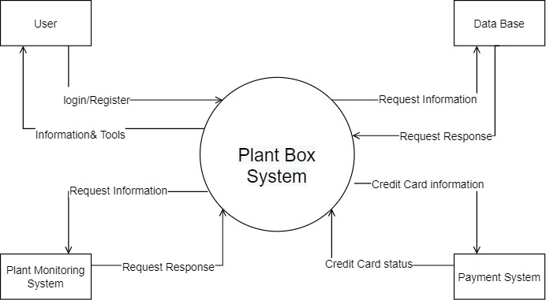

## 2.1.1 Data flow diagram

This is the level 0 data flow diagram of plant box application, where we have elaborated the high-level process of the application. It’s a basic overview of the whole System or process being analyzed or modeled. It’s designed to be an at-a-glance view of monitoring, add box and Confirm payment showing the system as a single high-level process.

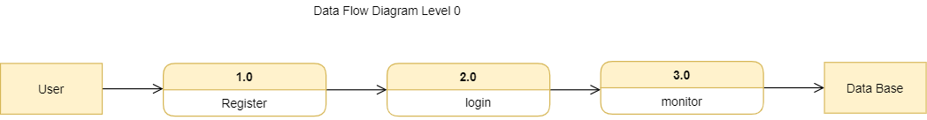

## Level 1 data flow diagram

A Smart Plant Box Application provide to its customers to create their own accounts, view their successful project, update their profile information, monitor and control and view live their plant status and application will request from them to enter their information such that email, name, password, city Where this information’s will be stored into database.

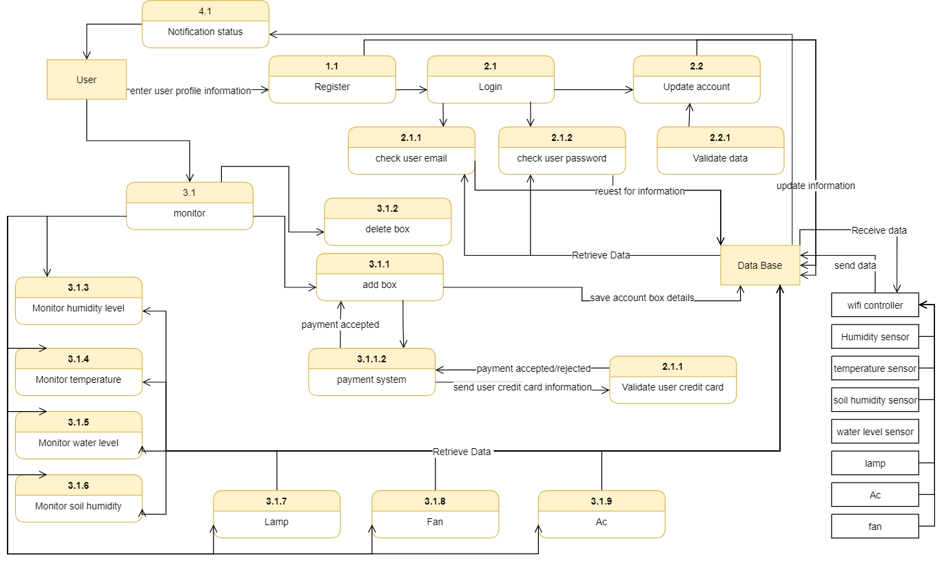

## 2.1.2 System requirements

* Java
* C++
* Nodemcu (Wi-Fi controller)
* Sensors back (humidity, temperature, water level)
* Humidity ac
* Water bump

## 2.1.2.1 Use-case Diagrams

A use case diagram at its simplest is a representation of a user's interaction with the system that shows the relationship between the user and the different use cases in which the user is involved. A use case diagram can identify the different types of users of a system and the different use cases and will often be accompanied by other types of diagrams as well.

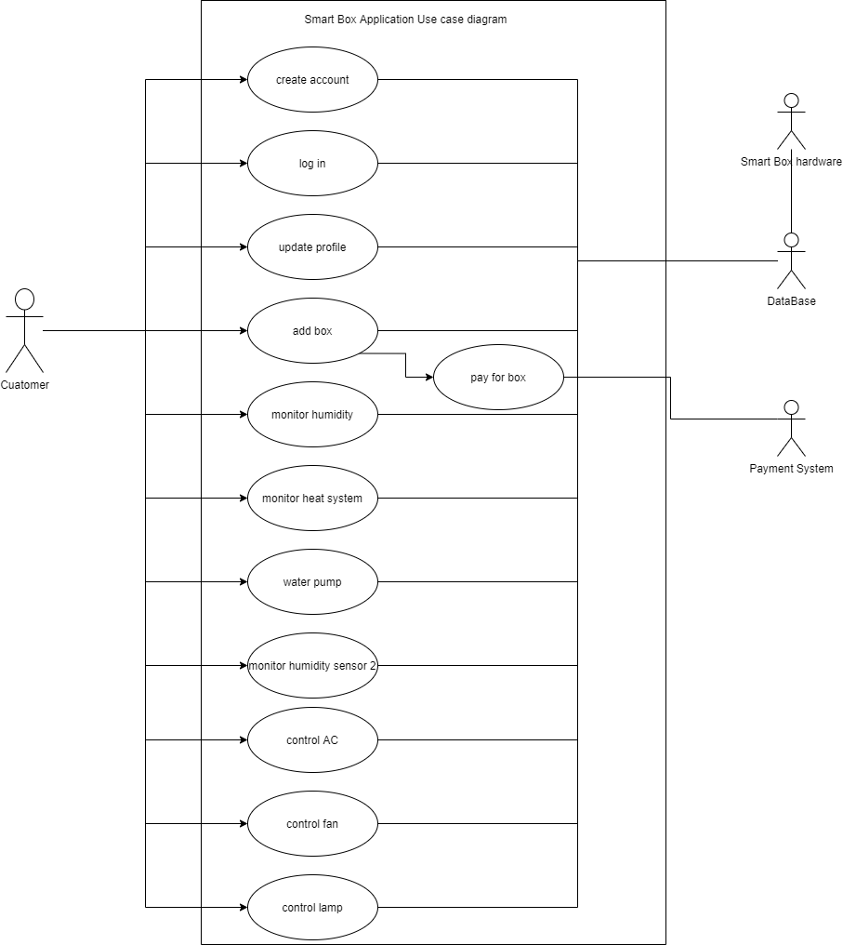

|  |  |
| --- | --- |
| Use case name | Smart Plant box |
| Actor | user |
| Description | describes the process how’s customer able to control and view plant box information’s through his account |
| Normal course | 1. User can **create account** after installing the application. 2. Actor can **log in** through his email and password. 3. **Check User data** authenticate the email and the user password. 4. Actor can **log out** from his account. 5. Actor can **add plant boxes** as much as he wants. 6. Actor can **pay** for the box through credit card. 7. **Check credit card status** through payment system. 8. Actor can **monitor** his box. 9. Actor can **control** light ON/OFF. 10. Actor get a **notification** for smart plant box status. |
| Alternate course | 1. If the user enters a wrong password or email the application informs him to try again. 2. If the user forgot his password, he/she can reset password. 3. The communication with the application database cannot be contacted the customer cannot use the application 4. The communication with the smart box database cannot be contacted the customer cannot view, or control box status. |
| Pre- condition | 1. The actor should have a smartphone to download the app 2. The customer should have a mail account 3. The customer should have a working credit card to buy the box 4. The user should have a Wi-Fi connection |
| Post- condition | 1. The actor should but the plants he/she want to plant 2. The actor should check on the plants from time to time. 3. The |

## 2.1.2.2 Functional and data requirements

* The system should allow users to create an account by their email, first and last name, password, phone number, city.
* The system should allow users to sign in by enter their email and password.
* The system should allow users to reset their password in forgot case.
* The system should allow users to update their profile information.
* The system should allow users to add boxes how and customize their names.
* The system should allow users to pay through credit card securely.
* The system should allow users to track their boxes information’s (heat, water, humidity)
* The system should send notification to users with the condition of their boxes and if there a problem if caused.
* The system should give the ability to users to close the app when they are in request.
* The system should allow users to delete specific box.
* The system should allow users to logout.

## 2.1.2.3 Non-functional requirements

* The system shall provide a graphic and colourful view and shall appear artistic
* The system clear.
* The system should be available 24 hours.
* Database independence.
* Usability: System should be easy to manage and use
* Reliability: System should be reliable and contain no error (Incremental model

apply).

* Privacy: The system should protect user privacy in advance (using private attribute) and log in.
* Compatible: The application should be compatible with the work environment which use android os.

## 2.1.2.3.1 Look and feel requirements

* Apparently simple to use
* Approachable, people do not hesitate to use it
* Authoritative, so that users feel they can rely on it and trust it
* Conforming to the client’s other product
* Professional looking
* Exciting
* Cool

## 2.1.2.3.2 Usability requirements

Smart plant box application is easy and simple to use and with live sensors status with high efficiency and satisfaction

## 2.1.2.3.3 Security requirements

The system will be secure and will protect user data

## 2.1.2.3.4 Portability requirements

The system will work with all android OS with the minimum hardware requirements

## 2.1.3 Class Diagrams

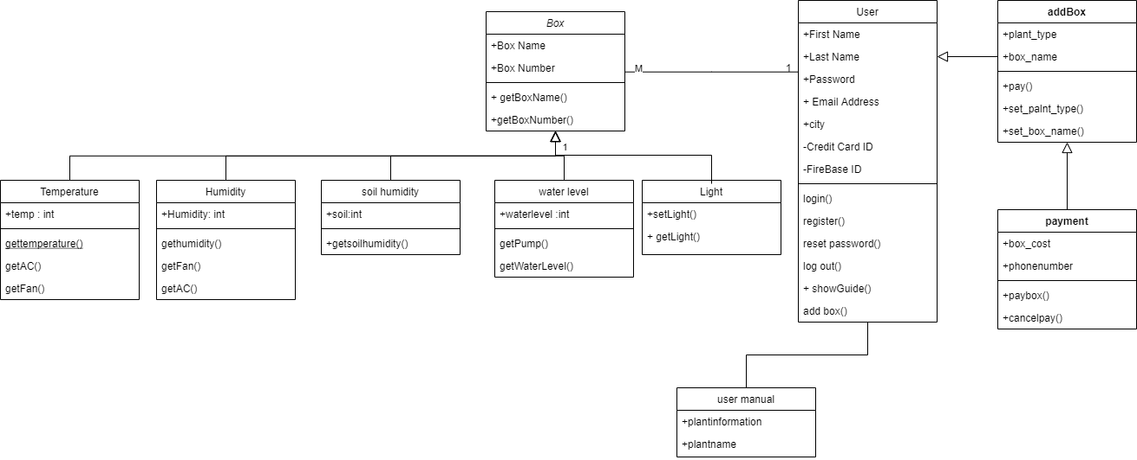

## 2.1.4 Proposed Solutions

Due to climate change and the traditional agriculture has become a burden on the farmer, and the agricultural area is gradually decreasing, in addition to the fact that many people in cities suffer from the lack of suitable agricultural areas, and also many suffer from the lack of a suitable environment for agriculture such as dry and desert areas. and cold, also they may not have the necessary experience to keep up with the planting process.

through this project to help provide an appropriate environment for planting and growing plants, such as seasonal plants and plants that need special environments, as well as mushroom cultivation, due to the difficulty of cultivation and the difficulty of creating the appropriate conditions and controlling the surrounding environment, and the need for high experience.

## 2.1.5 Alternative Solutions

* Develop efficient, self-sufficient and economical production systems that provide decent incomes
* Preserve and protect biodiversity and territories
* Optimize the use of natural resources
* Manage the quality of air, water and soil
* Increase energy efficiency in food production and distribution

# Chapter 3 DESIGN CONSIDERATIONS

## 3.1 Design constraints

Time: Learning new programing language such as java and how to deal with Arduino and hardware components

Resources: Choosing the best and the right components to create a friendly user interface.

Standards: java is the fundamental source code of our application,

Earlier Coursework: During our studies at the computer science department, we have taken some classes that helped us in the development of this project:

• The Database course: this course was necessary to build the database, storage system and relations in our project.

• The C++ courses: it was the main course that we utilized. It includes basics of handling with other language that we used in the development of the project.

## 3.1.1 Hardware and software environment

Hardware: we tried our best to provide the best user usability to use the smart box freely and portable the smart box consists of a fan, sensor for humidity, temperature sensor, water pump, humidity sensor2 for the plant itself.

Software: the user will allow to download and use the app from any android smartphone

After that he/she can create account to save his smart boxes data and the application allows the user to monitor and view many of the hardware sensors and plan status in time and live data

And the user can contact our support team if he/she has a question or need some help

## 3.1.2 End user characteristics

When we thought of the automated plant box it wasn’t It was not intended for a specific age group just the user or the actor in this scenario must be know how to use a smart phone and have a WIFI connection to connect with the automated box

## 3.2 Architectural Strategies

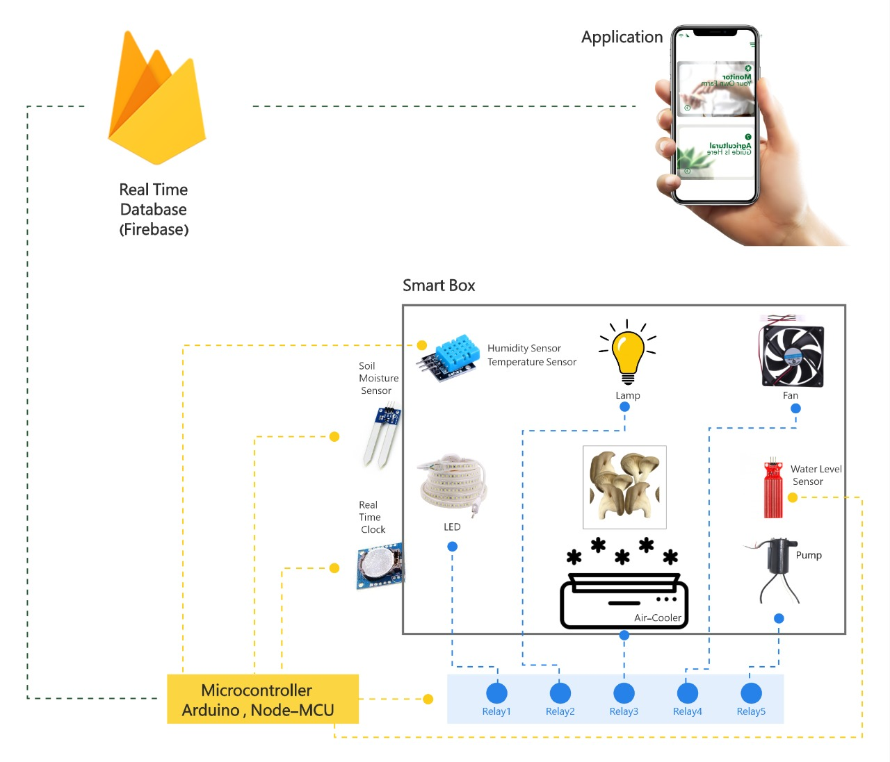3.2.1 Algorithm to be used

**plant disease detection**

One of the advantages of the application is the possibility of knowing the plant and predicting some of its diseases through photographing plant leaves.

We did our study on 14 plants and some of their diseases we documented and compared with more than 70,000 images.

|  |  |
| --- | --- |
| Plants | Disease |
| Apple | * scab * Black rot * Cedar apple rust |
| Cherry | * Powdery mildew |
| Corn | * Cercospora leaf spot * Gray leaf spot * Common rust * Northern Leaf Blight |
| Grape | * Black rot * Grape Esca (Black Measles) * Leaf blight(Isariopsis Leaf Spot) |
| Orange | * Haunglongbing (Citrus greening) |
| Peach | * Bacterial spot |
| Pepper | * Bacterial spot |
| Potato | * Early blight * Late blight |
| Squash | * Powdery mildew |
| Strawberry | * Leaf scorch |
| Tomato | * Bacterial_spot * Early_blight * Late_blight * Leaf_Mold * Septoria_leaf_spot * Spider_mites Two-spotted_spider_mite * Target_Spot * Tomato_Yellow_Leaf_Curl_Virus * Tomato_mosaic_virus |
| Raspberry(Healthy) |  |
| Soybean(Healthy) |  |
| Blueberry(Healthy) |  |

The Tensor flow and Kera’s library (image processing specialists) was used in the data training process and the Platform we used Colab from google .



CNN:

A Convolutional Neural Network (ConvNet/CNN) is a Deep Learning algorithm which can take in an input image, assign importance (learnable weights and biases) to various aspects/objects in the image and be able to differentiate one from the other.

We used it to build our model:



Api architecture:

We upload image to python to predict plant disease through Api(flask).

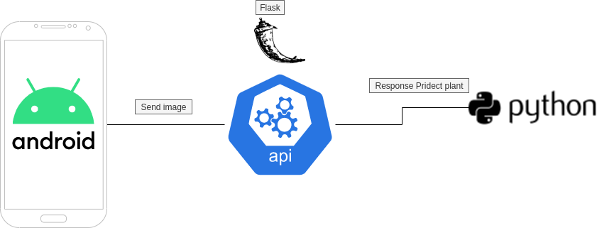

After training the data:

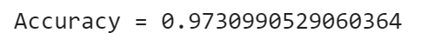

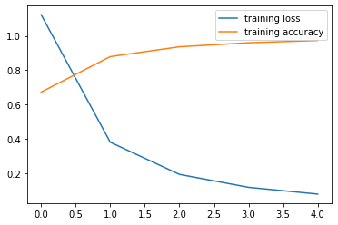

## NTP Protocol

An NTP stands for Network Time Protocol. It’s a standard Internet Protocol (IP) for synchronizing the computer clocks to some reference over a network.

The protocol can be used to synchronize all networked devices to Coordinated Universal Time (UTC) within a few milliseconds ( 50 milliseconds over the public Internet and under 5 milliseconds in a LAN environment).

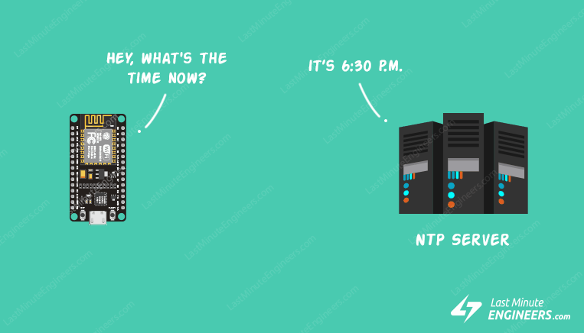

How NTP Works?

NTP can operate in a number of ways. The most common configuration is to operate in client-server mode. The basic working principle is as follows:

The client device such as ESP8266 connects to the server using the User Datagram Protocol (UDP) on port 123.

A client then transmits a request packet to a NTP server.

In response to this request the NTP server sends a time stamp packet.

A time stamp packet contains multiple information like UNIX timestamp, accuracy, delay or time zone.

A client can then parse out current date & time values.

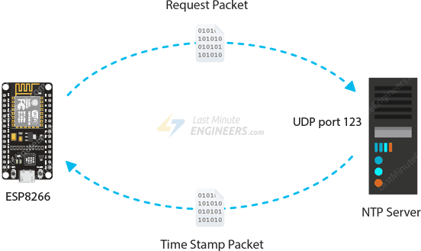

## 3.2.2 Project management strategies

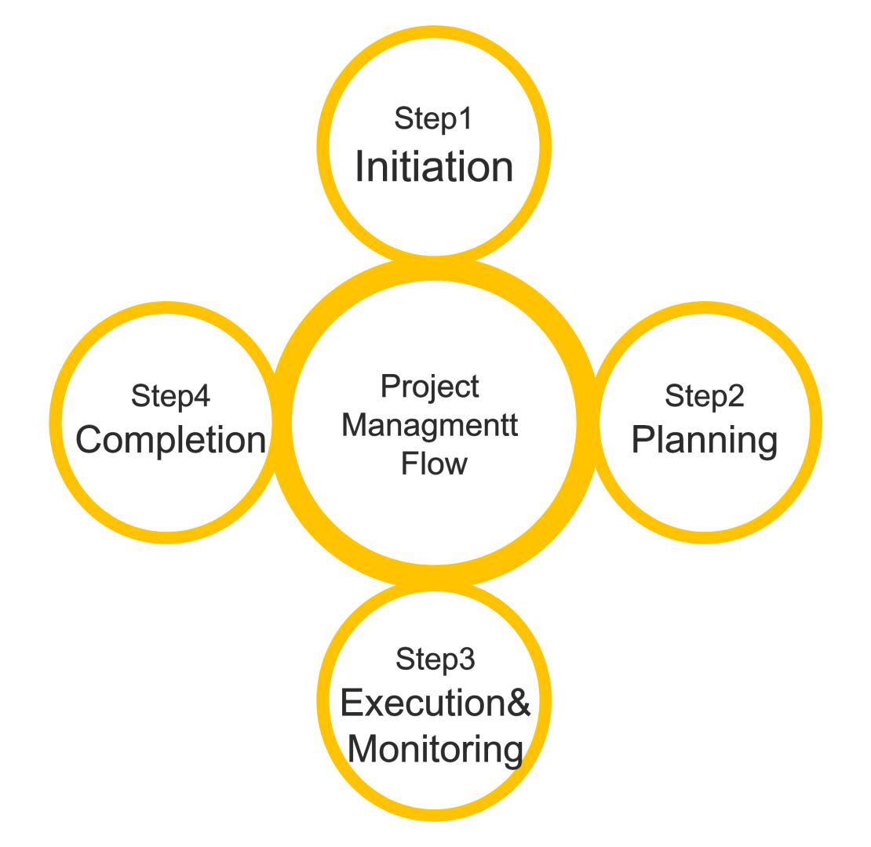

## 3.2.3 Development method

We used in development method the Waterfall development method 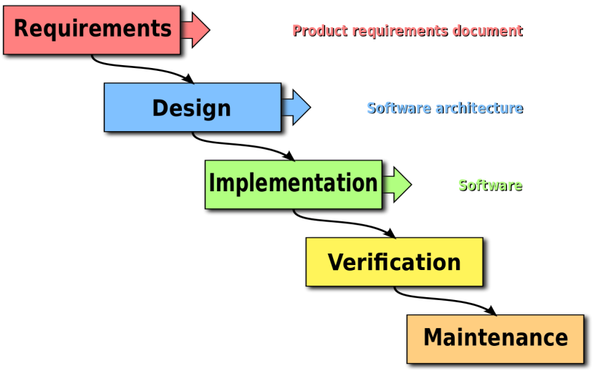

## 3.2.4 Future enhancements/plans

In the future after the project transfers to the customer phase they will be some modifications on the smart box like the look the sensors the humidity system and it will be available with different sizes

And in the software phase the application will be more advanced with an ai system that recognize the condition of the plant itself if its ready to be pick or if the life condition of it not good or if it is dead and will be add more sensors

# Chapter 4 SYSTEM DESIGN

In chapter 4 we will show how the system designed and how the program flow through phases from where to where.

## 4.1Architecture and Program Flow

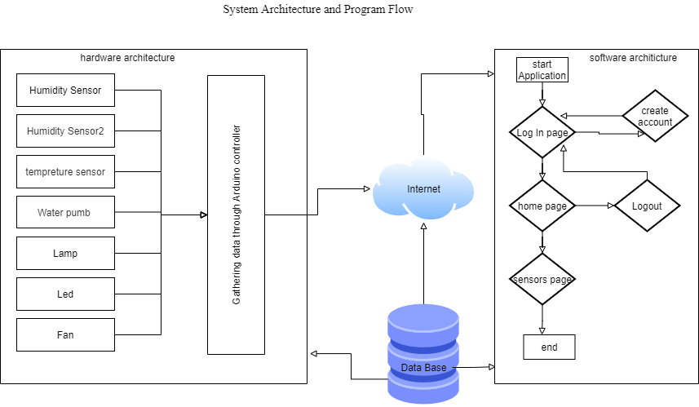

4.1.1 Major modules

There are some main modules in the project which are further classified into different sub-modules that are.

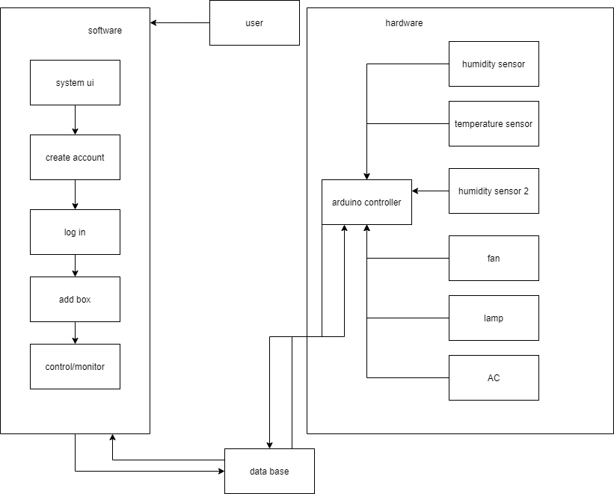

## 4.2.1 Detailed System Design

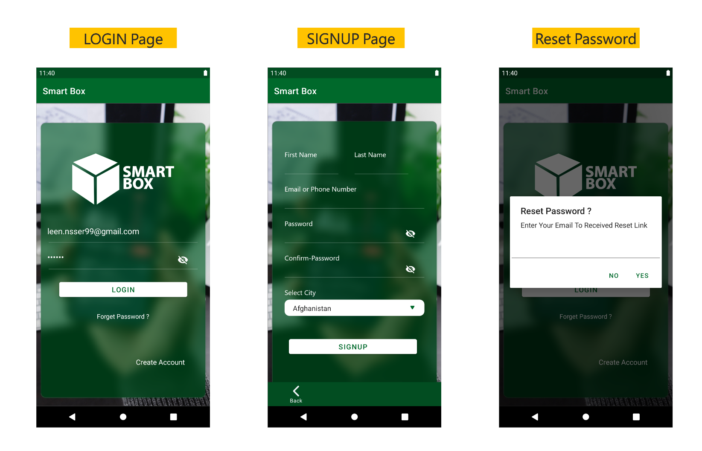

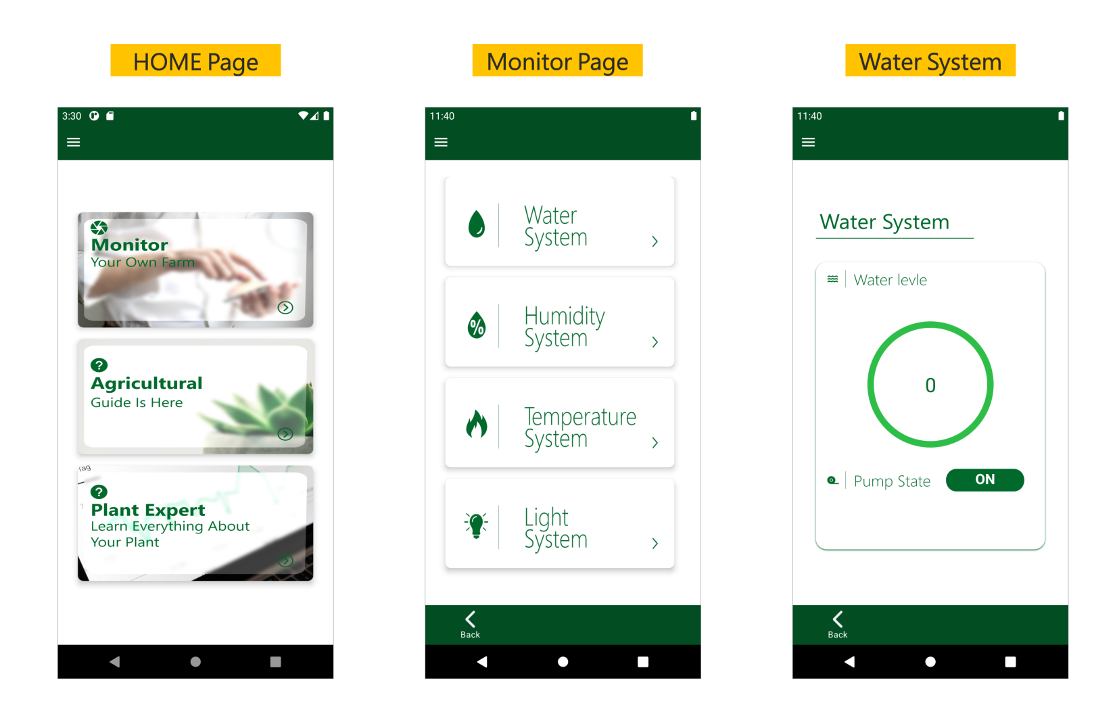

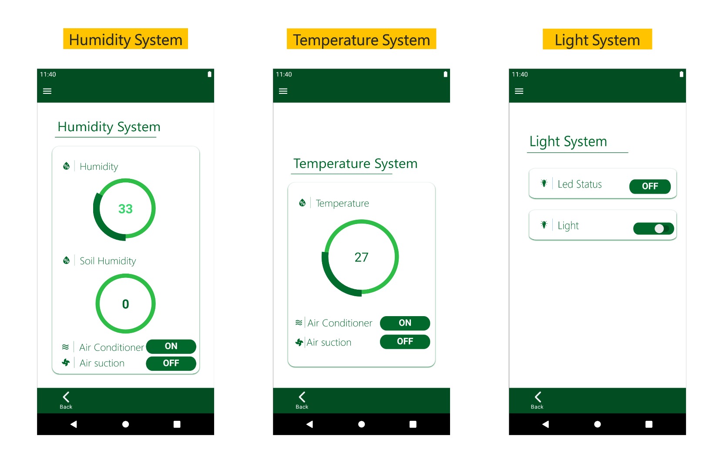

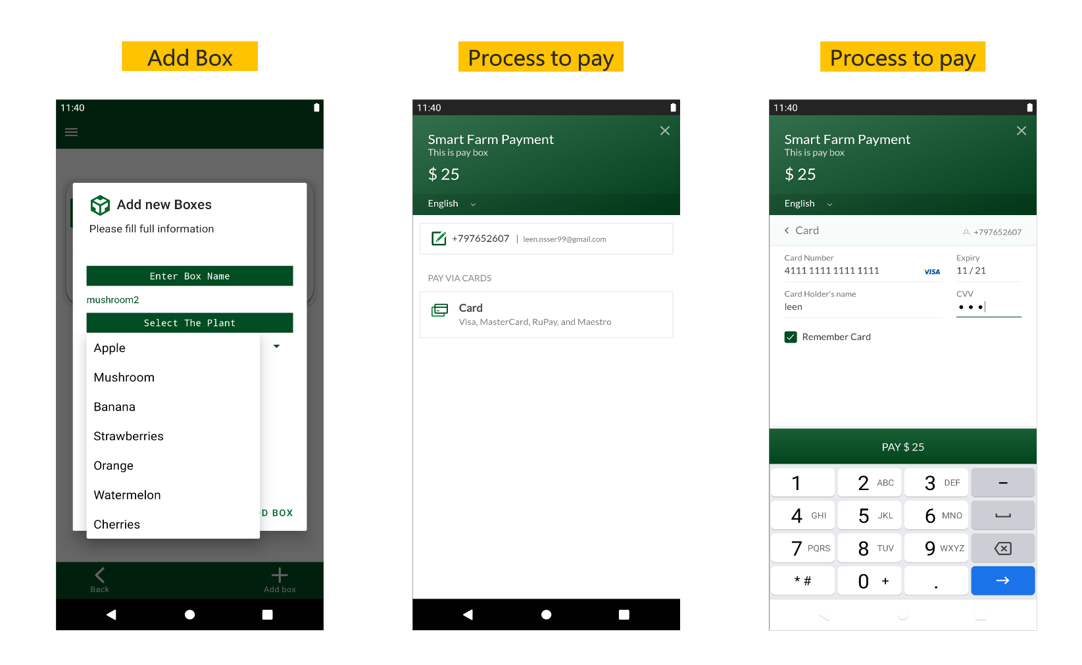

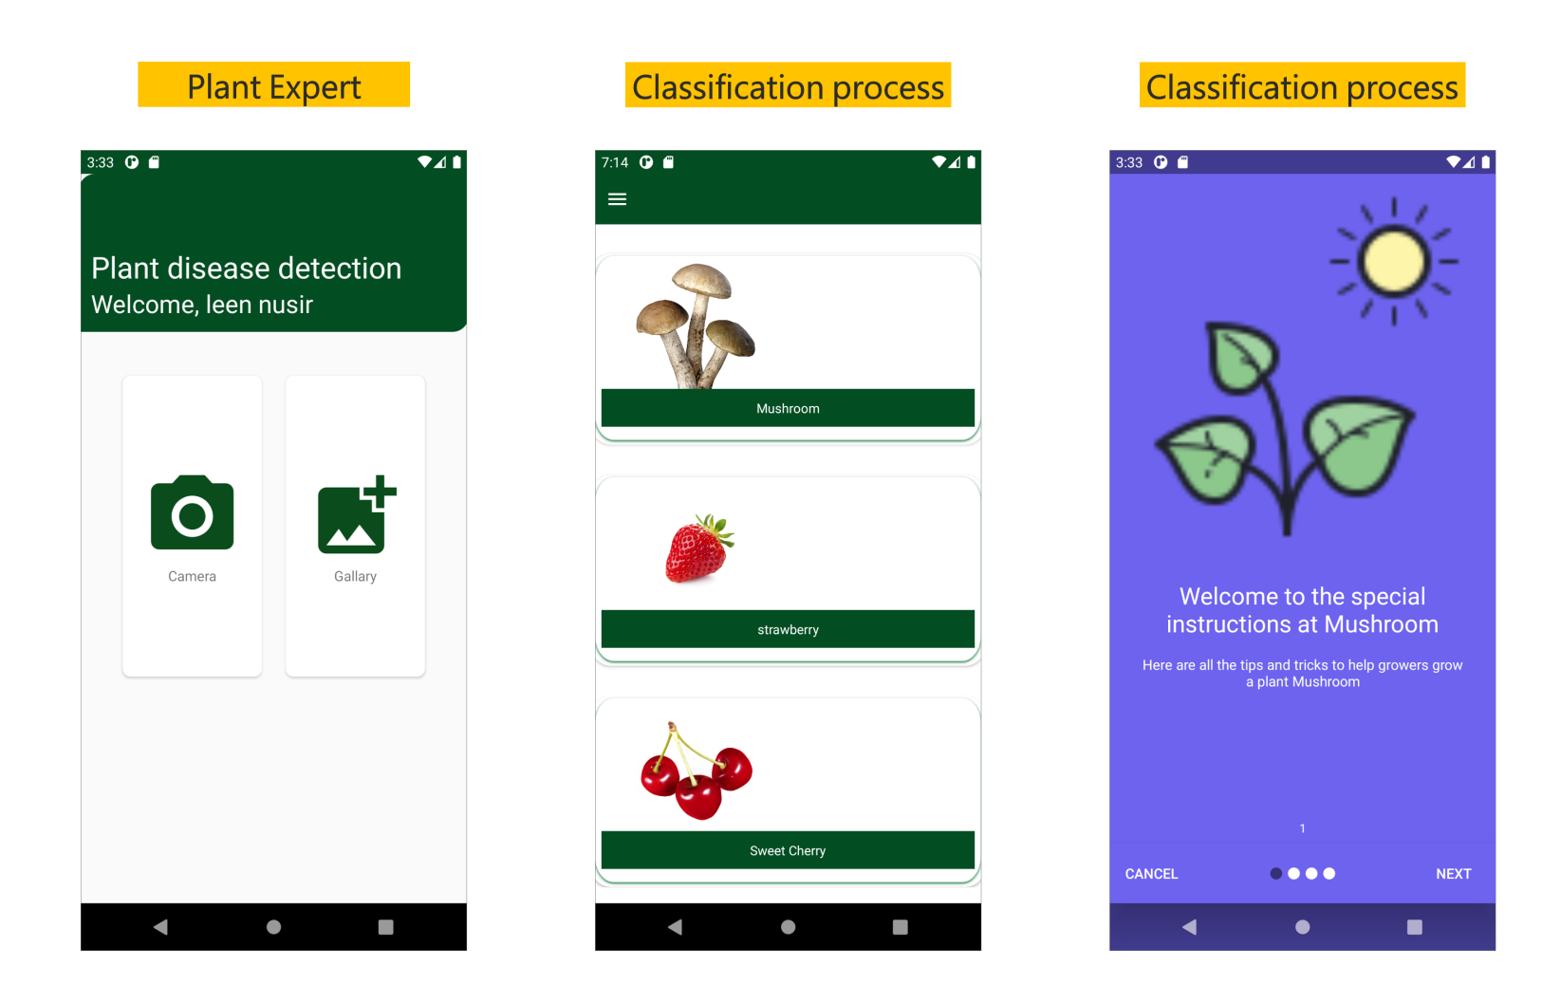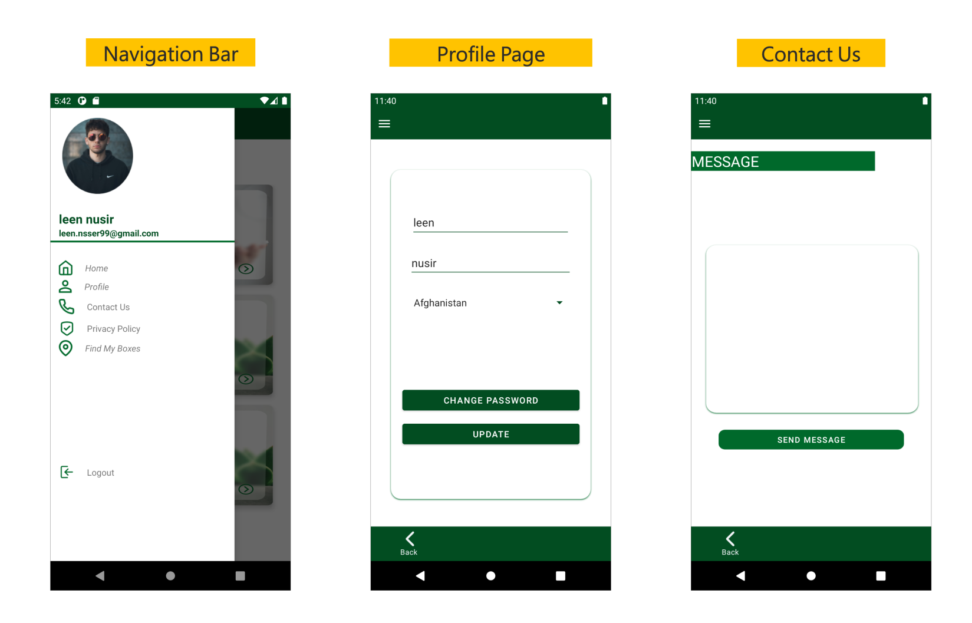

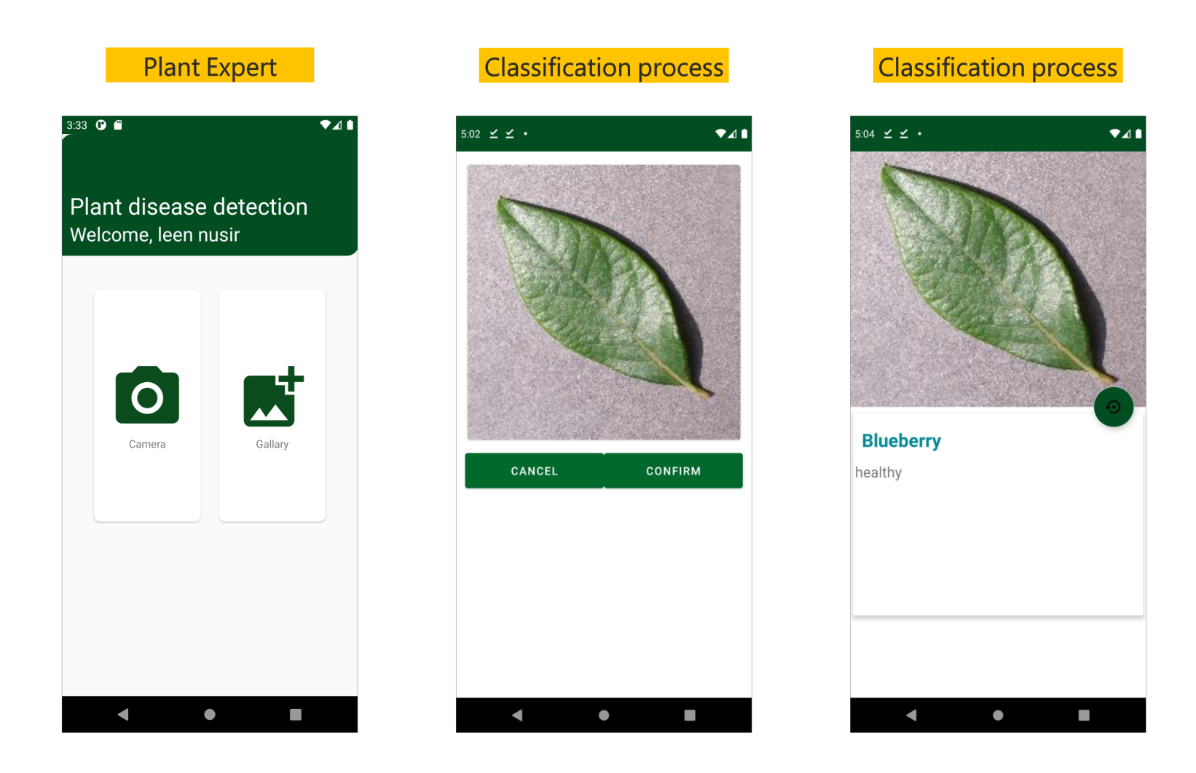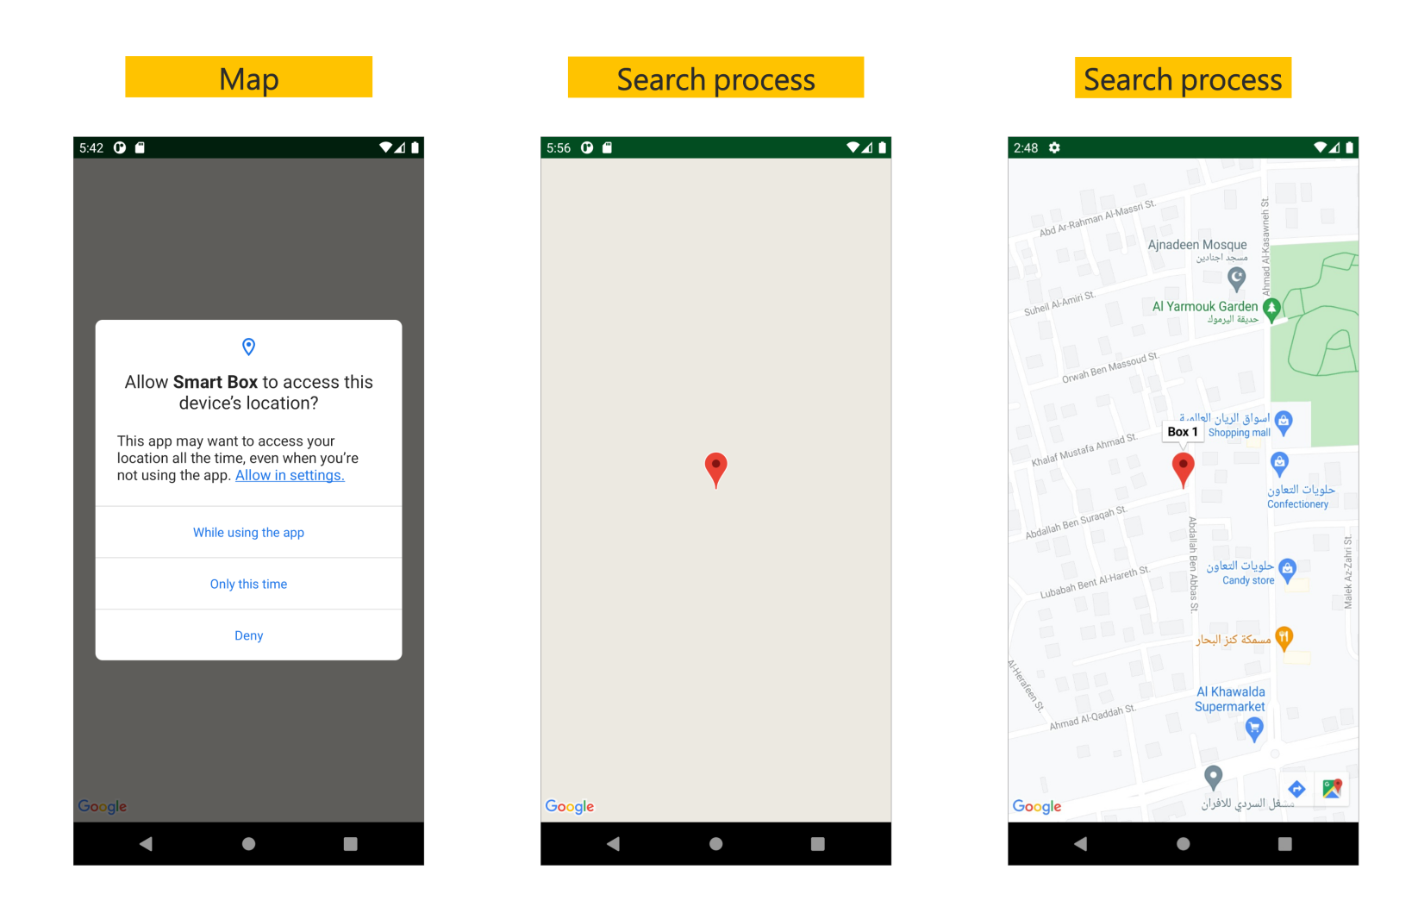

## 4.2.2Detailed component description

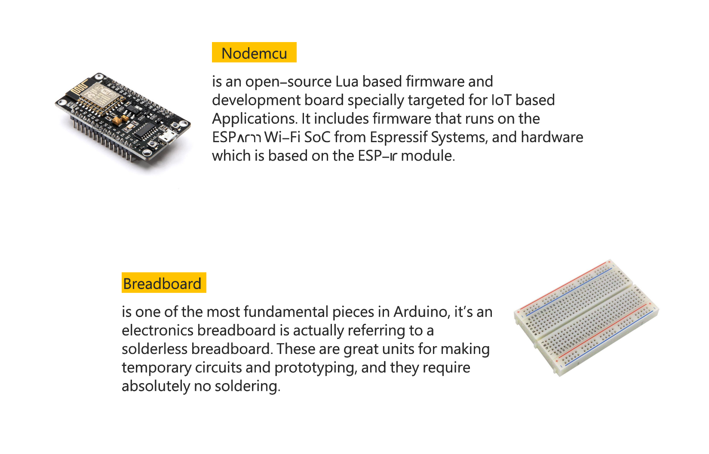

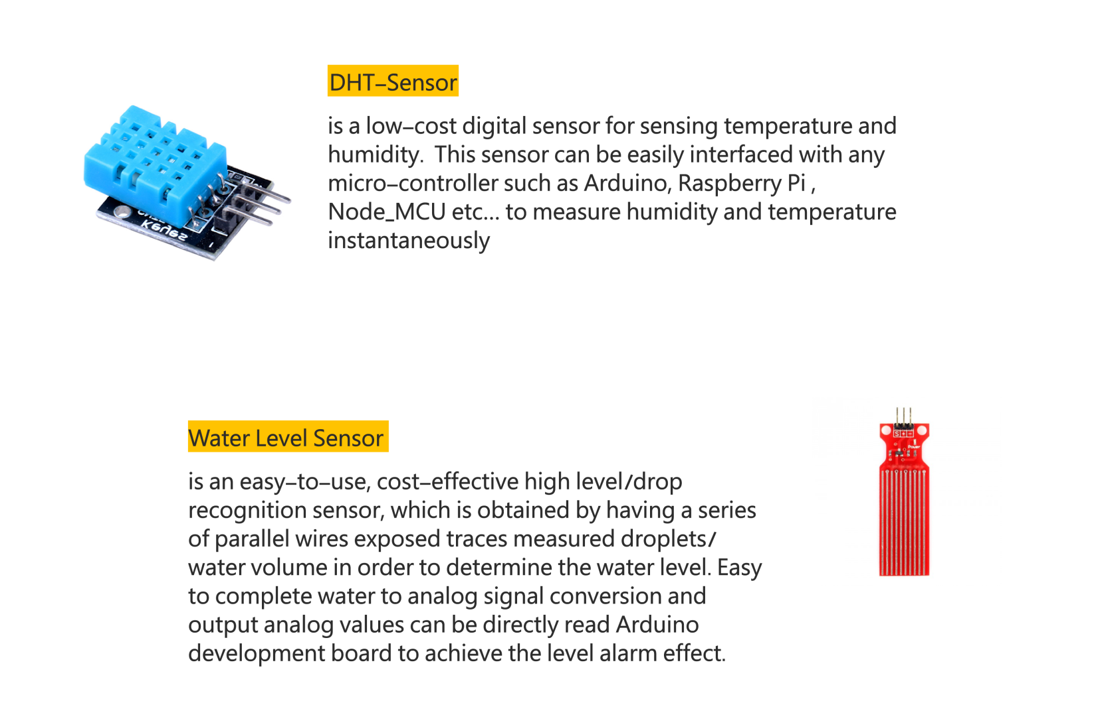

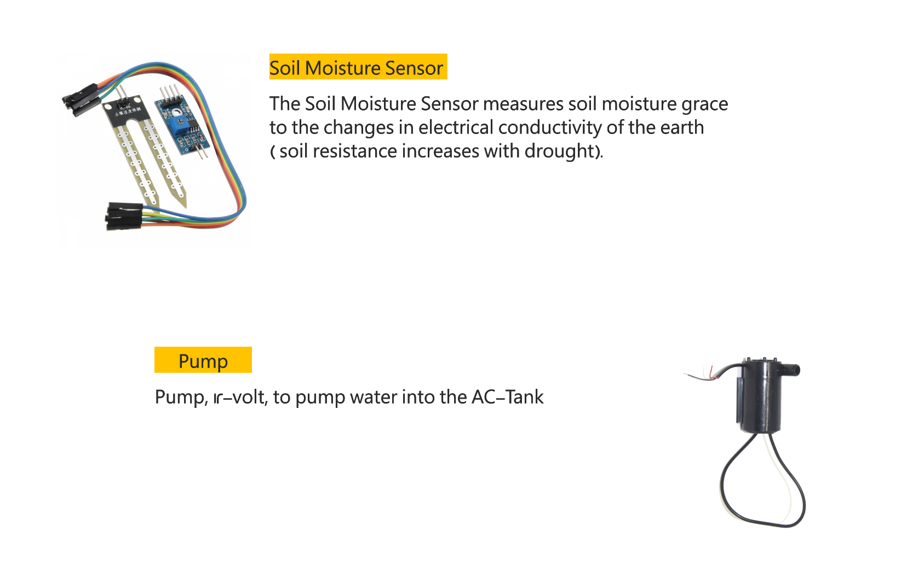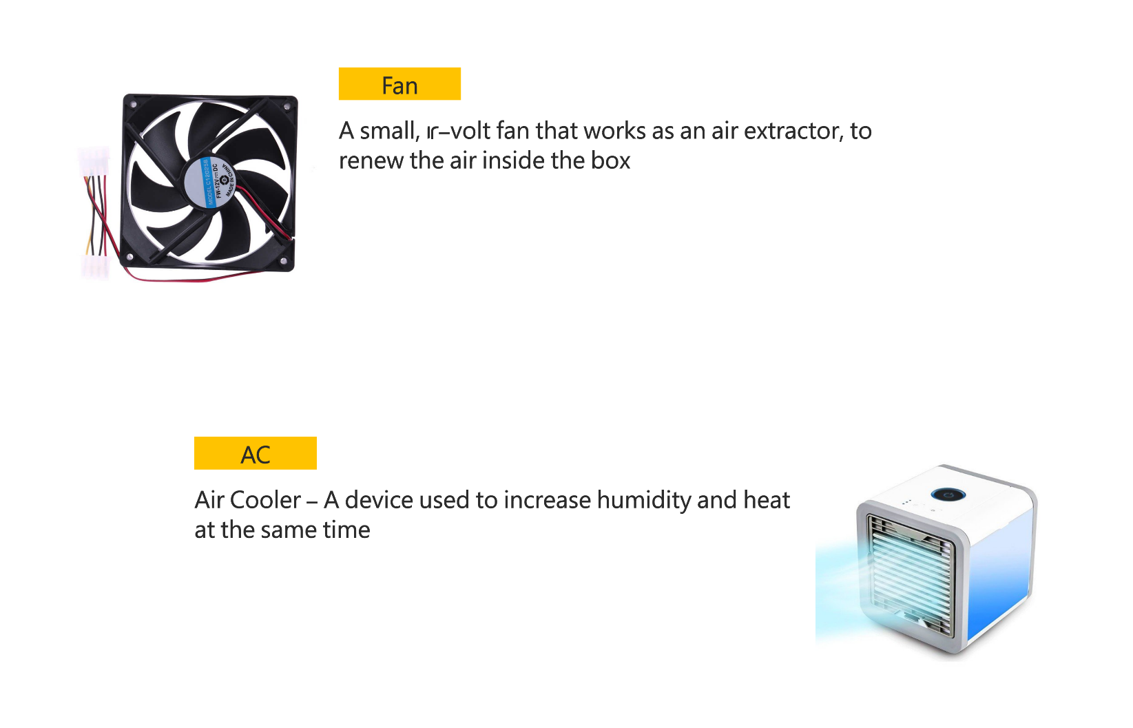

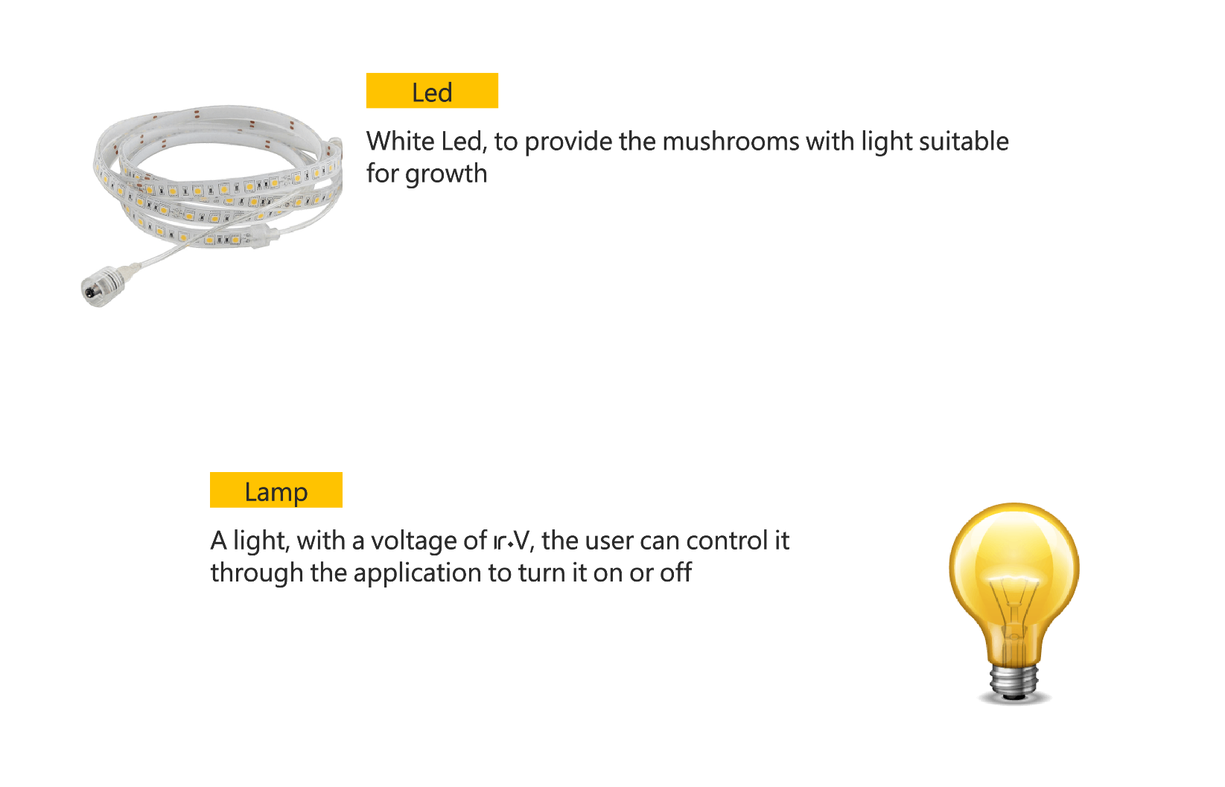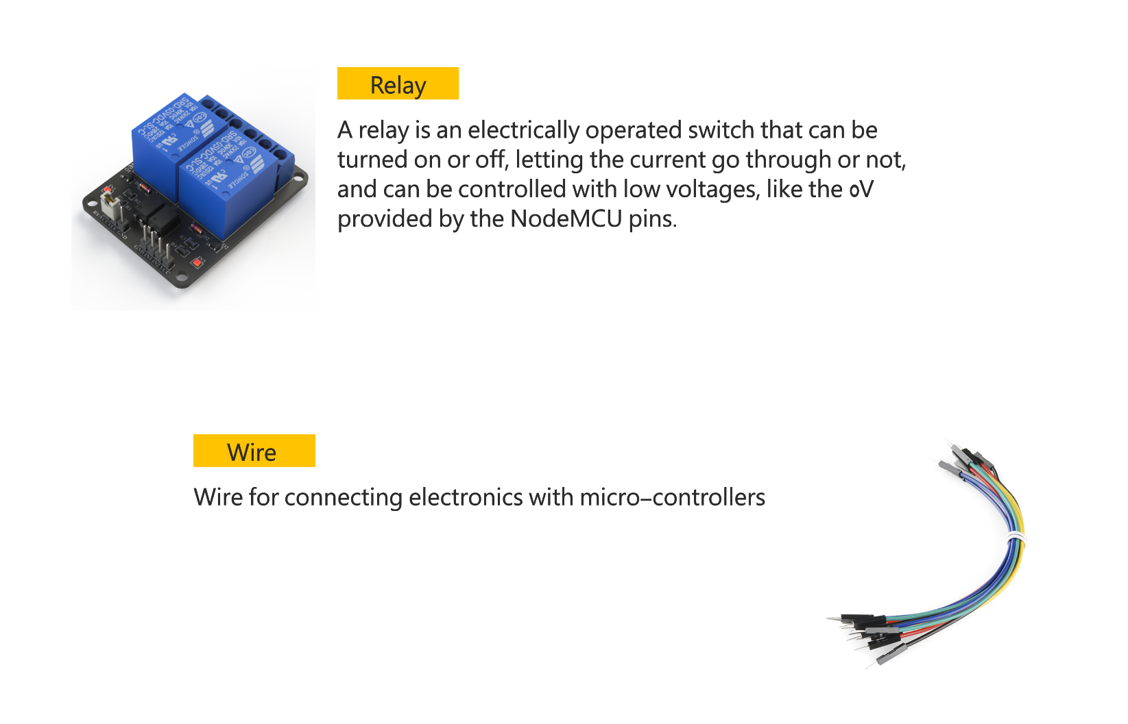

# Chapter 5 IMPLEMENTATION AND VALIDATION

**Appendix A CODE**

## Code Of Android studio**:**

Here we list some of the project main functions,

1. Boxes code that gets boxes information from firebase

package com.example.agriculturalproject.Models;  
  
public class Boxes {  
 String img, name, plant, userId, Led, Temperature, Humidity, Soil_Moisture, Water_Level, pump, AC,Fan ,Led_auto,id_box; // String name from FB (حرفيا)  
  
 public Boxes() {  
 }  
  
 public Boxes(String img, String name, String plant, String userId, String led, String temperature,  
 String humidity, String soil_Moisture, String water_Level, String pump, String AC, String fan, String led_auto) {  
 this.img = img;  
 this.name = name;  
 this.plant = plant;  
 this.userId = userId;  
 Led = led;  
 Temperature = temperature;  
 Humidity = humidity;  
 Soil_Moisture = soil_Moisture;  
 Water_Level = water_Level;  
 this.pump = pump;  
 this.AC = AC;  
 Fan = fan;  
 Led_auto = led_auto;  
 }  
  
 public String getImg() {  
 return img;  
 }  
  
 public void setImg(String img) {  
 this.img = img;  
 }  
  
 public String getName() {  
 return name;  
 }  
  
 public void setName(String name) {  
 this.name = name;  
 }  
  
 public String getPlant() {  
 return plant;  
 }  
  
 public void setPlant(String plant) {  
 this.plant = plant;  
 }  
  
 public String getUserId() {  
 return userId;  
 }  
  
 public void setUserId(String userId) {  
 this.userId = userId;  
 }  
  
 public String getLed() {  
 return Led;  
 }  
  
 public void setLed(String led) {  
 Led = led;  
 }  
  
 public String getTemperature() {  
 return Temperature;  
 }  
  
 public void setTemperature(String temperature) {  
 Temperature = temperature;  
 }  
  
 public String getHumidity() {  
 return Humidity;  
 }  
  
 public void setHumidity(String humidity) {  
 Humidity = humidity;  
 }  
  
 public String getSoil_Moisture() {  
 return Soil_Moisture;  
 }  
  
 public void setSoil_Moisture(String soil_Moisture) {  
 Soil_Moisture = soil_Moisture;  
 }  
  
 public String getWater_Level() {  
 return Water_Level;  
 }  
  
 public void setWater_Level(String water_Level) {  
 Water_Level = water_Level;  
 }  
  
 public String getPump() {  
 return pump;  
 }  
  
 public void setPump(String pump) {  
 this.pump = pump;  
 }  
  
 public String getAC() {  
 return AC;  
 }  
  
 public void setAC(String AC) {  
 this.AC = AC;  
 }  
  
 public String getFan() {  
 return Fan;  
 }  
  
 public void setFan(String fan) {  
 Fan = fan;  
 }  
  
 public String getLed_auto() {  
 return Led_auto;  
 }  
  
 public void setLed_auto(String led_auto) {  
 Led_auto = led_auto;  
 }  
  
 public String getId_box() {  
 return id_box;  
 }  
  
 public void setId_box(String id_box) {  
 this.id_box = id_box;  
 }  
}

1. Users code to get user information from firebase
2. package com.example.agriculturalproject.Models;  
     
   public class Users {  
    String FirstName , LastName , Email ,Password , Select ,Img ;  
     
    public Users() {  
    }  
     
    public Users(String firstName, String lastName, String email, String password ,String select , String img) {  
    FirstName = firstName;  
    LastName = lastName;  
    Email = email;  
    Password = password;  
    Select = select;  
    Img = img;  
     
    }  
     
    public String getImg() {  
    return Img;  
    }  
     
    public void setImg(String img) {  
    Img = img;  
    }  
     
    public String getFirstName() {  
    return FirstName;  
    }  
     
    public void setFirstName(String firstName) {  
    FirstName = firstName;  
    }  
     
    public String getLastName() {  
    return LastName;  
    }  
     
    public void setLastName(String lastName) {  
    LastName = lastName;  
    }  
     
    public String getEmail() {  
    return Email;  
    }  
     
    public void setEmail(String email) {  
    Email = email;  
    }  
     
    public String getPassword() {  
    return Password;  
    }  
     
    public void setPassword(String password) {  
    Password = password;  
    }  
     
    public String getSelect() {  
    return Select;  
    }  
     
    public void setSelect(String select) {  
    Select = select;  
    }  
   }
3. **Log in code** that gets its data from firebase which also contains reset password for user

import androidx.annotation.NonNull;  
import androidx.appcompat.app.AlertDialog;  
import androidx.appcompat.app.AppCompatActivity;  
  
import android.content.DialogInterface;  
import android.content.Intent;  
import android.os.Bundle;  
import android.view.View;  
import android.widget.Button;  
import android.widget.EditText;  
import android.widget.TextView;  
import android.widget.Toast;  
  
import com.example.agriculturalproject.GlobalClasses.Global;  
import com.example.agriculturalproject.Models.Users;  
import com.google.android.gms.tasks.OnCompleteListener;  
import com.google.android.gms.tasks.OnFailureListener;  
import com.google.android.gms.tasks.OnSuccessListener;  
import com.google.android.gms.tasks.Task;  
import com.google.firebase.auth.AuthResult;  
import com.google.firebase.auth.FirebaseAuth;  
import com.google.firebase.database.DataSnapshot;  
import com.google.firebase.database.DatabaseError;  
import com.google.firebase.database.DatabaseReference;  
import com.google.firebase.database.FirebaseDatabase;  
import com.google.firebase.database.ValueEventListener;  
  
public class MainActivity extends AppCompatActivity {  
 EditText email_phone , password ;  
 TextView forget ,crate;  
 Button login , api_python;  
 FirebaseAuth fAuth;  
 DatabaseReference databaseReference;  
  
 private FirebaseAuth mAuth;//authentication(email,password)(to check the email and password correct from fb)  
 @Override  
 protected void onCreate(Bundle savedInstanceState) {  
 super.onCreate(savedInstanceState);  
 setContentView(R.layout.*activity_main*);  
 mAuth = FirebaseAuth.*getInstance*();  
  
 email_phone = findViewById(R.id.*edt_email_phone*);  
 password = findViewById(R.id.*edt_pass*);  
 forget = findViewById(R.id.*edt_for*);  
 crate = findViewById(R.id.*edt_cna*);  
 login = findViewById(R.id.*btn_log*);  
 fAuth = FirebaseAuth.*getInstance*();  
 databaseReference = FirebaseDatabase.*getInstance*().getReference().child("Users");//access to all data about this user  
 // Users==table  
  
 api_python = findViewById(R.id.*btn_log2*);  
 api_python.setOnClickListener(new View.OnClickListener() {  
 @Override  
 public void onClick(View v) {  
 startActivity(new Intent(MainActivity.this, ChooseImagePhoto.class));  
  
 }  
 });  
 crate.setOnClickListener(new View.OnClickListener() {  
  
  
 @Override  
 public void onClick(View v) {  
  
 startActivity(new Intent(MainActivity.this,RegisterUser.class));  
 }  
 });  
 login.setOnClickListener(new View.OnClickListener() {  
 @Override  
 public void onClick(View v) {  
 String email_phone_str = email_phone.getText().toString().trim() ;//trim== remove whitespace  
 String password_str = password.getText().toString().trim() ;  
  
 if (email_phone_str.isEmpty()){  
  
 Toast.*makeText*(MainActivity.this, "The Email is empty", Toast.*LENGTH_SHORT*).show();  
  
 return;  
 }  
 if(password_str.isEmpty())  
 {  
 Toast.*makeText*(MainActivity.this, "The Password is empty", Toast.*LENGTH_SHORT*).show();  
 return;  
 }else {  
 if(password_str.length() < 6){  
 Toast.*makeText*(MainActivity.this, "The Password length < 6 ", Toast.*LENGTH_SHORT*).show();  
 return;  
 }  
 }  
  
 mAuth.signInWithEmailAndPassword(email_phone_str , password_str).addOnCompleteListener(new OnCompleteListener<AuthResult>() {  
 @Override  
 public void onComplete(@NonNull Task<AuthResult> task) {  
 if(task.isSuccessful()){//task== sign operation  
 databaseReference.addListenerForSingleValueEvent(new ValueEventListener() {  
 @Override  
 public void onDataChange(@NonNull DataSnapshot snapshot) {  
 Users user = snapshot.child(FirebaseAuth.*getInstance*().getCurrentUser().getUid()).getValue(Users.class);//snapshot==control in data(update,delete,insert ,getValue)  
 Global.*currentUser* = user;//user static var. to make stable in all sys.(account)  
 //  
 startActivity(new Intent(MainActivity.this , MainHome.class));//go to home page  
  
 }  
  
 @Override  
 public void onCancelled(@NonNull DatabaseError error) {//  
 Toast.*makeText*(MainActivity.this, "Dis connect on firebase", Toast.*LENGTH_SHORT*).show();  
 } }); }  
 else  
 Toast.*makeText*(MainActivity.this, "The password or email is wrong", Toast.*LENGTH_SHORT*).show();//if i enter wrong email and password  
}});}  
 });  
 forget.setOnClickListener(new View.OnClickListener() {  
 @Override  
 public void onClick(View v) {  
 EditText resetMail = new EditText(v.getContext());//getContext==access to make edit text  
 AlertDialog.Builder PasswordRestDialog = new AlertDialog.Builder(v.getContext());  
 PasswordRestDialog.setTitle("Reset Password ?");  
 PasswordRestDialog.setMessage("Enter Your Email To Received Reset Link");  
 PasswordRestDialog.setView(resetMail);  
 PasswordRestDialog.setPositiveButton("Yes", new DialogInterface.OnClickListener() {  
 @Override  
 public void onClick(DialogInterface dialog, int which) {  
 // EXTRACT THE EMAIL & SEND RESET LINK  
 String mail = resetMail.getText().toString();  
 fAuth.sendPasswordResetEmail(mail).addOnSuccessListener(new OnSuccessListener<Void>() {  
 @Override  
 public void onSuccess(Void aVoid) {  
 Toast.*makeText*(MainActivity.this, "Reset Link To Your Email", Toast.*LENGTH_SHORT*).show();  
 }  
 }).addOnFailureListener(new OnFailureListener() {  
 @Override  
 public void onFailure(@NonNull Exception e) {  
 Toast.*makeText*(MainActivity.this, "Error ! Reset Link Is Not Sent"+e.getMessage(), Toast.*LENGTH_SHORT*).show();  
 }  
 });  
 }  
 });  
 PasswordRestDialog.setNegativeButton("No", new DialogInterface.OnClickListener() {  
 @Override  
 public void onClick(DialogInterface dialog, int which) {  
 // CLOSE THE DIALOG  
 }  
 });  
 PasswordRestDialog.create().show();  
  
 }  
 });  
   
 }  
}

1. Register page code to create account

import androidx.annotation.NonNull;  
import androidx.appcompat.app.AppCompatActivity;  
  
import android.content.Intent;  
import android.os.Bundle;  
import android.util.Patterns;  
import android.view.MenuItem;  
import android.view.View;  
import android.widget.ArrayAdapter;  
import android.widget.Button;  
import android.widget.EditText;  
import android.widget.Spinner;  
import android.widget.Toast;  
  
import com.example.agriculturalproject.Models.Users;  
import com.google.android.gms.tasks.OnCompleteListener;  
import com.google.android.gms.tasks.Task;  
import com.google.android.material.bottomnavigation.BottomNavigationView;  
import com.google.firebase.auth.AuthResult;  
import com.google.firebase.auth.FirebaseAuth;  
import com.google.firebase.database.FirebaseDatabase;  
  
import java.util.ArrayList;  
import java.util.Collections;  
import java.util.Locale;  
  
public class RegisterUser extends AppCompatActivity {  
 EditText FirstName , LastName , EmailPhone , Password_reg, Confirm_reg ;  
 Button SignUp;  
 private FirebaseAuth mAuth;//register operation to fb  
 Spinner select;//to select city  
  
 @Override  
 protected void onCreate(Bundle savedInstanceState) {  
 super.onCreate(savedInstanceState);  
 setContentView(R.layout.*activity_register_user*);  
  
 FirstName = findViewById(R.id.*edt_reg_first_name*);  
 LastName = findViewById(R.id.*edt_reg_last_name*);  
 EmailPhone = findViewById(R.id.*edt_reg_email_phone*);  
 Password_reg = findViewById(R.id.*edt_reg_pass*);  
 Confirm_reg = findViewById(R.id.*edt_reg_pass_confirm*);  
 SignUp = findViewById(R.id.*btn_reg_signup*);  
 select = findViewById(R.id.*spinner_id*);  
  
  
 mAuth = FirebaseAuth.*getInstance*();  
  
  
 //SELECT CITY BUTTON (CODE)  
 Locale[] locales = Locale.*getAvailableLocales*();//eVERY AVALBEL LOCATION  
 ArrayList<String> countries = new ArrayList<String>();//put them in array list (countries )  
 for (Locale locale : locales) {//loop in every local  
 String country = locale.getDisplayCountry();// extract country from local  
 if (country.trim().length() > 0 && !countries.contains(country)) {//IF COUNTRY LENGTH LESS THAN 0 (empty )AND EXIST IN LIST(country must be unique)  
 countries.add(country);  
 }  
 }  
  
 Collections.*sort*(countries);//alphabetical sort  
  
 ArrayAdapter<String> countryAdapter = new ArrayAdapter<String>(this,//for sppiner(store country in sppiner)  
 android.R.layout.*simple_spinner_item*, countries);  
  
 countryAdapter.setDropDownViewResource(R.layout.*spinner_layout*);  
 // Apply the adapter to the your spinner  
 select.setAdapter(countryAdapter);  
  
 SignUp.setOnClickListener(new View.OnClickListener() {  
 @Override  
 public void onClick(View v) {  
 String edt_reg_f_name_str = FirstName.getText().toString().trim() ;  
 String edt_reg_l_name_str = LastName.getText().toString().trim() ;  
 String edt_reg_email_str = EmailPhone.getText().toString().trim();  
 String edt_reg_pass_str = Password_reg.getText().toString().trim();  
 String edt_reg_confirm_str = Confirm_reg.getText().toString().trim();  
 String edt_reg_select_city = select.getSelectedItem().toString();  
  
 if (edt_reg_f_name_str.isEmpty()){  
 Toast.*makeText*(RegisterUser.this, "The First Name Is Empty", Toast.*LENGTH_SHORT*).show();  
 return;}  
  
 if (edt_reg_l_name_str.isEmpty()){  
 Toast.*makeText*(RegisterUser.this, "The Last Name Is Empty", Toast.*LENGTH_SHORT*).show();  
 return;}  
  
  
 if (edt_reg_email_str.isEmpty()){  
 Toast.*makeText*(RegisterUser.this, "The Email Is Empty", Toast.*LENGTH_SHORT*).show();  
 return;}  
  
  
 if(edt_reg_pass_str.isEmpty())  
 {  
 Toast.*makeText*(RegisterUser.this, "The password is empty", Toast.*LENGTH_SHORT*).show();  
 return;  
 }else {  
 if(edt_reg_pass_str.length() < 6){  
 Toast.*makeText*(RegisterUser.this, "The password length < 6 ", Toast.*LENGTH_SHORT*).show();  
 return;  
 }  
 }  
  
 if (edt_reg_confirm_str.isEmpty()){  
 Toast.*makeText*(RegisterUser.this, "The Confirm Password Is Empty", Toast.*LENGTH_SHORT*).show();  
 return;}  
 if (!edt_reg_pass_str.equals(edt_reg_confirm_str))  
 {  
 Toast.*makeText*(RegisterUser.this, "The Confirm Password Is Error", Toast.*LENGTH_SHORT*).show();  
 return;  
 }  
  
  
 //TO CHICK THE EMAIL FORMAT IS CORRECT  
 if(!Patterns.*EMAIL_ADDRESS*.matcher(edt_reg_email_str).matches()){  
 Toast.*makeText*(RegisterUser.this, "INCORRECT EMAIL", Toast.*LENGTH_SHORT*).show();  
 return;  
 }  
 //TO MAKE RECORD IN FIREBASE  
 mAuth.createUserWithEmailAndPassword(edt_reg_email_str,edt_reg_pass_str).addOnCompleteListener(new OnCompleteListener<AuthResult>() {//add account in fb  
 @Override  
 public void onComplete(@NonNull Task<AuthResult> task) {  
 if(task.isSuccessful()){  
 Toast.*makeText*(RegisterUser.this, "The record success", Toast.*LENGTH_SHORT*).show();  
 Users user = new Users(edt_reg_f_name_str , edt_reg_l_name_str , edt_reg_email_str ,edt_reg_pass_str,edt_reg_select_city,"https://i.ibb.co/PNJXysd/blankprofilepicture973460640.png");  
 //Object from record (insert realtime database)  
 FirebaseDatabase.*getInstance*().getReference("Users").//هو المسؤول عن اضاف recourd كلاسuser في fb  
 child(FirebaseAuth.*getInstance*().getCurrentUser().getUid()).setValue(user).  
 addOnCompleteListener(new OnCompleteListener<Void>() {  
 @Override  
 public void onComplete(@NonNull Task<Void> task) {  
 if (task.isSuccessful())  
 {  
 Toast.*makeText*(RegisterUser.this, "Complete", Toast.*LENGTH_SHORT*).show();  
 startActivity(new Intent(RegisterUser.this , MainActivity.class));  
  
  
 }  
 else  
 Toast.*makeText*(RegisterUser.this, "not Complete ", Toast.*LENGTH_SHORT*).show();  
 }  
 });  
  
 }else {  
 Toast.*makeText*(RegisterUser.this, "The registration not complete", Toast.*LENGTH_SHORT*).show();//ont insert record in Auth()  
  
 }  
  
 }  
 });  
  
 }  
 });  
 BottomNavigationView btmNav = findViewById(R.id.*bottom_register*);  
 btmNav.setOnNavigationItemReselectedListener(new BottomNavigationView.OnNavigationItemReselectedListener() {  
 @Override  
 public void onNavigationItemReselected(@NonNull MenuItem item) {  
 switch (item.getItemId())  
 {  
 case R.id.*register_back*:  
 finish();//back to login home  
  
 break;  
 }  
  
 }  
  
 });  
  
  
 }  
}

## Code Of Hardware (Arduino):

|  |  |
| --- | --- |
| 1  2  3  4  5  6  7  8  9  10  11  12  13  14  15  16  17  18  19  20  21  22  23  24  25  26  27  28  29  30  31  32  33  34  35  36  37  38  39  40  41  42  43  44  45  46  47  48  49  50  51  52  53  54  55  56  57  58  59  60  61  62  63  64  65  66  67  68  69  70  71  72  73  74  75  76  77  78  79  80  81  82  83  84  85  86  87  88  89  90  91  92  93  94  95  96  97  98  99  100  101  102  103  104  105  106  107  108  109  110  111  112  113  114  115  116  117  118  119  120  121  122  123  124  125  126  127  128  129 | ***#include <Firebase.h>***  ***#include <FirebaseArduino.h>***  ***#include <FirebaseCloudMessaging.h>***  ***#include <FirebaseError.h>***  ***#include <FirebaseHttpClient.h>***  ***#include <FirebaseObject.h>***  ***#include <Arduino_JSON.h>***  ***#include <ESP8266WiFi.h>***  ***#define FIREBASE_HOST "agricultural-project-598a0-default-rtdb.firebaseio.com"***  ***#define FIREBASE_AUTH "R3SWyUeYXAryBFJfdhCjHHp5Qjf8w97o8zqdggDE"***  /*#define ssid "Zainbroadband1_15FAAE"  ***#define password "NMDE4XFJ"***  ***#include "DHT.h"*** *// including the library of DHT11 temperature and humidity sensor*  ***#define DHTTYPE DHT11*** *// DHT 11*  ***#define dht_dpin 2*** *//D4*  DHT dht(dht_dpin, DHTTYPE);  ***#include <NTPClient.h>***  ***#include <ESP8266WiFi.h>***  ***#include <WiFiUdp.h>***  **const** **long** utcOffsetInSeconds = **3600**;  **char** daysOfTheWeek[**7**][**12**] = {"Sunday", "Monday", "Tuesday", "Wednesday", "Thursday", "Friday", "Saturday"};  *// Define NTP Client to get time*  WiFiUDP ntpUDP;  NTPClient **timeClient**(ntpUDP, "asia.pool.ntp.org", utcOffsetInSeconds);  **int** led = **4**; *//D2;*  **int** led_Auto = **12**; *//D6;*  **int** fan = **13**; *//D7*  String status_led ;  **const** **int** sensor_pin = A0;  **int** pump= **8**;  ***#define watersensorPin A1***  **int** value;  **void** **setup**()  {  dht.begin();  Serial.begin(**115200**);  Serial.println("Humidity and temperature\n\n");  delay(**500**);  WiFi.disconnect();  WiFi.begin(ssid , password);  Serial.println("connecting....");  **while**( WiFi.status() != WL_CONNECTED){  delay (**50**);  Serial.println("."); }  Serial.println(".");  Serial.println("connected");  Serial.println(WiFi.localIP());  pinMode ( led , OUTPUT );  pinMode ( fan , OUTPUT );  pinMode ( led_Auto, OUTPUT );  digitalWrite ( led_Auto, HIGH);  digitalWrite ( fan, HIGH);  Firebase.set("Boxes/-MZT-_W4Ib79xESLf_D4/Led","ON");  Firebase.begin(FIREBASE_HOST ,FIREBASE_AUTH );  Firebase.setString ( "Boxes/-MZT-_W4Ib79xESLf_D4/Humidity", "80");  Firebase.setString ("Boxes/-MZT-_W4Ib79xESLf_D4/Temperature", "20");  Firebase.setString ("Boxes/-MZT-_W4Ib79xESLf_D4/Soil_Moisture", "20");  Firebase.setString ("Boxes/-MZT-_W4Ib79xESLf_D4/Fan", "OFF");  Firebase.setString ( "Boxes/-MZT-_W4Ib79xESLf_D4/Led_auto" ,"OFF" );  Firebase.setString ("Boxes/-MZT-_W4Ib79xESLf_D4/Water_Level", "300");  Firebase.setString ( "Boxes/-MZT-_W4Ib79xESLf_D4/pump" ,"OFF" );  timeClient.begin(); }  **void** **loop**()  {  timeClient.update();  **if** ((timeClient.getMinutes() >= **50**) && (timeClient.getMinutes()<**56** )){  digitalWrite ( fan, LOW);  Firebase.setString ( "Boxes/-MZT-_W4Ib79xESLf_D4/Fan" ,"ON" );  }  **else** {  digitalWrite ( fan, HIGH);  Firebase.setString ( "Boxes/-MZT-_W4Ib79xESLf_D4/Fan" ,"OFF" );}  **if**((timeClient.getHours()+**2** >= **8**) && (timeClient.getHours()+**2** <**16** )){  digitalWrite ( led_Auto, LOW);  Firebase.setString ( "Boxes/-MZT-_W4Ib79xESLf_D4/Led_auto" ,"ON" );}  **else** { digitalWrite ( led_Auto, HIGH);  Firebase.setString ( "Boxes/-MZT-_W4Ib79xESLf_D4/Led_auto" ,"OFF" );}  **float** h = dht.readHumidity();  **float** t = dht.readTemperature();  Serial.print("Current humidity = ");  Serial.print(h);  Serial.print("% ");  Serial.print("temperature = ");  Serial.print(t);  Serial.println("C ");  **if** ( h <= **95** || t >= **22** ){  Firebase.setString ( "Boxes/-MZT-_W4Ib79xESLf_D4/AC" ,"ON" ); }  **else** { Firebase.setString ( "Boxes/-MZT-_W4Ib79xESLf_D4/AC" ,"OFF" ) ;}  String h_FB = String (h);  String t_FB = String (t);  Firebase.setString ( "Boxes/-MZT-_W4Ib79xESLf_D4/Humidity" ,h_FB );  Firebase.setString ( "Boxes/-MZT-_W4Ib79xESLf_D4/Temperature" ,t_FB );  status_led = Firebase.getString("Boxes/-MZT-_W4Ib79xESLf_D4/Led");  **if** (status_led == "true")  {  Serial.println("Led Turned ON");  digitalWrite(led, LOW);  }  **else** **if** (status_led == "false")  {  Serial.println("Led Turned OFF");  digitalWrite(led, HIGH);  }  **else**  {  Serial.println("Command Error! Please send ON/OFF");  }  **float** moisture_percentage;  moisture_percentage = ( **100.00** - ( (analogRead(sensor_pin)/**1023.00**) * **100.00** ) );  String Soil_Moisture = String (moisture_percentage);  Firebase.setString ( "Boxes/-MZT-_W4Ib79xESLf_D4/Soil_Moisture" , Soil_Moisture );  Serial.print("Soil Moisture(in Percentage) = ");  Serial.print(moisture_percentage);  Serial.println("%");  value = analogRead(watersensorPin);  String Water_level = String (value);  Firebase.setString ( "Boxes/-MZT-_W4Ib79xESLf_D4/Water_Level" ,Water_level );  Serial.print("Water level: ");  Serial.println(value);    **if** (value<=**300**){  Serial.println("Water level: 0mm - Empty!");  digitalWrite (pump , LOW) ;  Firebase.setString ( "Boxes/-MZT-_W4Ib79xESLf_D4/pump" ,"ON" );}  **else** **if** (value>**400** ){  digitalWrite (pump , HIGH) ;  Firebase.setString ( "Boxes/-MZT-_W4Ib79xESLf_D4/pump" ,"OFF" ); }  delay(**1000**);} |

## Code of Python (ML):

**import** matplotlib.pyplot **as** plt

**import** tensorflow **as** tf

**from** tensorflow.keras **import** layers

**import** numpy **as** np

**import** pandas **as** pd

**from** time **import** perf_counter

**import** os

batch_size = **100** *#size of sample in network*

image_size = (**250**, **250**)

seed = **42** *# random (shuffling,transformations)*

train = tf.keras.preprocessing.image_dataset_from_directory(

'/content/New Plant Diseases Dataset(Augmented)/New Plant Diseases Dataset(Augmented)/train',

seed=seed,

image_size= image_size,

batch_size=batch_size

)

test = tf.keras.preprocessing.image_dataset_from_directory(

'/content/New Plant Diseases Dataset(Augmented)/New Plant Diseases Dataset(Augmented)/valid',

seed=seed,

image_size= image_size,

batch_size=batch_size)

class_names = train.class_names

**print**(class_names) *#get class name*

model = tf.keras.models.Sequential([

layers.BatchNormalization(),

layers.Conv2D(**32**, **3**, activation='relu'),

layers.MaxPooling2D(),

layers.Conv2D(**64**, **3**, activation='relu'),

layers.MaxPooling2D(),

layers.Conv2D(**128**, **3**, activation='relu'),

layers.MaxPooling2D(),

layers.Flatten(),

layers.Dense(**256**, activation='relu'),

layers.Dense(len(class_names), activation= 'softmax')

])

model.compile(optimizer='adam',loss='sparse_categorical_crossentropy', metrics=['accuracy'])

retVal = model.fit(train,validation_data= test,epochs = **5**)

plt.plot(retVal.history['loss'], label = 'training loss')

plt.plot(retVal.history['accuracy'], label = 'training accuracy')

plt.legend()

**print**("Accuracy = "+str(retVal.history['accuracy'][**4**]))

model.save('model.h5')

# Appendix References

[**https://www.arduino.cc/**](https://www.arduino.cc/)

[**https://developers.google.com/maps/documentation/android-sdk/start**](https://developers.google.com/maps/documentation/android-sdk/start)

[**https://firebase.google.com/**](https://firebase.google.com/)

[**https://www.udemy.com/course/complete-android-n-developer-course/**](https://www.udemy.com/course/complete-android-n-developer-course/)

[**https://getstream.io/blog/use-github-android-studio/**](https://getstream.io/blog/use-github-android-studio/)

[**https://www.adobe.com/products/xd/features/ui-kits.html**](https://www.adobe.com/products/xd/features/ui-kits.html)

[**https://colab.research.google.com/drive/1YEe2VKyZuCdFzgj7NruVERxVYPGFxgFl?usp=sharing#scrollTo=Bqz1fQc2e11m**](https://colab.research.google.com/drive/1YEe2VKyZuCdFzgj7NruVERxVYPGFxgFl?usp=sharing#scrollTo=Bqz1fQc2e11m)

[**https://www.kaggle.com/**](https://www.kaggle.com/)

[**https://www.kaggle.com/emmarex/plantdisease**](https://www.kaggle.com/emmarex/plantdisease)

**BOOK: Android Application Development All-in-One For Dummies, 3rd Edition**

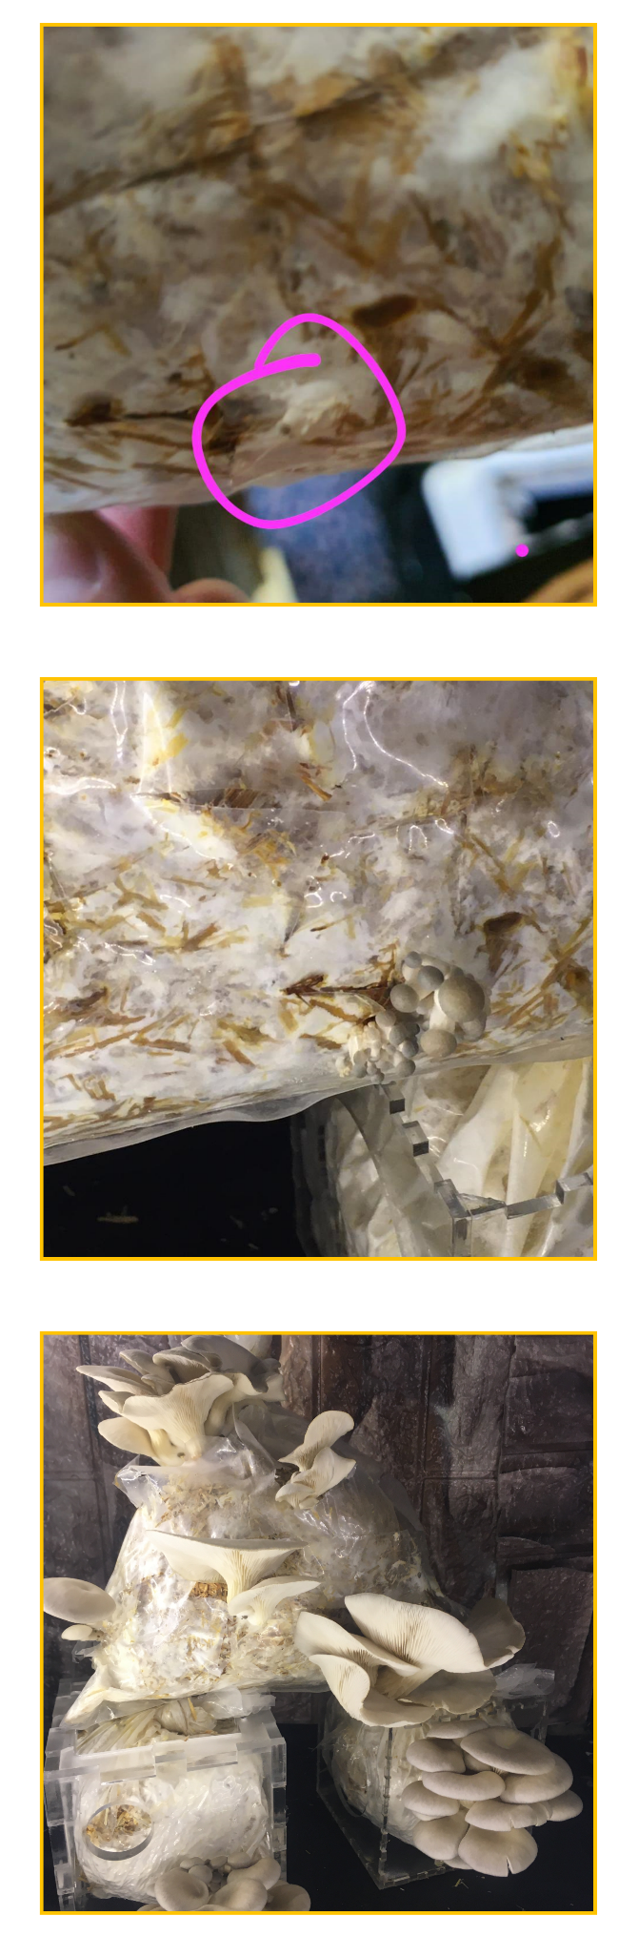

# Mushroom growth stages

# Software we used :